Task 1:
JPA – Java Persistence Api is a module used to access to access database. It reduces the boilerplate code for database processes. JPA provides repositories, query generations and other methods that makes database access easier.

Task 2:
Key features of JPA:
- ORM – Object relational mapping maps java objects to database tables automatically
- CRUD operations – simplifies CRUD operations using objects instead of tables.
- Automatic sql generation – generates sql statements based on mappings and operations
- Caching – improves performance by reducing repeated access
- Transaction management – ensures data consistency by grouping operations into atomic transactions

Task 3:
Core components of JPA:
- Entity – A Java class that represents a database table.
- EntityManager – Manages entity lifecycle and database operations.
- EntityManagerFactory – Creates and manages EntityManager instances.
- Persistence Context – Tracks and manages entity objects in memory.
- Persistence Unit – Defines JPA configuration, entities, and database settings.
- Persistence Provider – The implementation of JPA, such as Hibernate.
- JPQL – An object-oriented query language for querying entities.
- Criteria API – A type-safe API for building dynamic queries programmatically.
- Transactions – Ensure database operations execute as a single unit of work.
- Entity Relationships – Define associations between entities using mapping annotations.
- Annotations – Provide metadata for entity mapping and configuration.
- Named Queries – Predefined reusable queries defined at the entity level.

Task 4:
Done
Task 5:
Done

Task 6:
application.properties is the main configuration file in a Spring Boot application. It is used to store application settings such as the database connection details, application name, and other configuration values. Instead of hardcoding these values in Java code, they are kept in this file, making the application easier to configure and maintain.

Task 7:
Some uses of application.properties are:
- Setting the server port.
- Configuring database URL, username, and password.
- Setting the application name.
- Configuring logging levels.
- Enabling or disabling features.
- Defining custom application properties.

Task 8:
application.yml is configuration file used in Spring Boot. It serves the same purpose as application.properties but uses the YAML format, which is cleaner and easier to read, especially when dealing with nested configurations.

Task 9:
application.yml is preferred because:
- It is easier to read for large projects.
- Nested configurations are more organized.
- It reduces repeated property names.
- The file looks cleaner and is easier to maintain.

Task 10:
Eureka Server is a service registry used in microservices architecture. It keeps track of all the microservices running in the system. Instead of services remembering each other's IP addresses, they simply register with the Eureka Server, and other services can discover them whenever needed.

Task 11:
Use of eureka server:
• Registers all available microservices.
- Helps services discover each other.
- Avoids hardcoding IP addresses and ports.
- Supports load balancing by keeping track of multiple service instances.
- Makes the system more scalable and easier to manage.

Task 12:
Spring MVC (Model-View-Controller) is a web framework provided by Spring for building web applications and REST APIs. It follows the MVC design pattern, where the application is divided into three parts:
- Model – Holds the application's data and business logic.
- View – Displays the data to the user.
- Controller – Receives user requests, processes them, and returns the appropriate response.
This separation makes the application easier to develop, test, and maintain.

Task 13:
The Dispatcher Servlet is the central controller of the Spring MVC framework. It acts like a traffic police officer for incoming requests. Without the Dispatcher Servlet, Spring MVC wouldn't know where to send incoming requests.

Task 14:
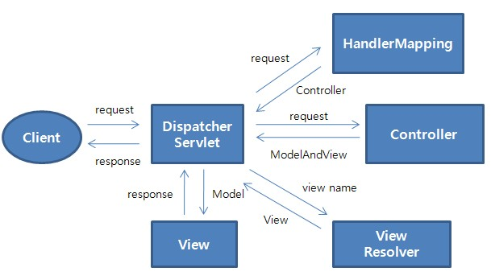
Soring mvc architecture

- Client sends a request to the application.
- Dispatcher Servlet receives the request.
- Handler Mapping finds the correct Controller.
- Controller processes the request and returns ModelAndView (data + view name).
- Dispatcher Servlet sends the view name to the View Resolver.
- View Resolver finds the actual View (JSP/HTML/Thymeleaf).
- Dispatcher Servlet passes the Model (data) to the View.
- View generates the response and sends it back to the Client.

